Pizza Cafe Sales Analysis

* **Queries for KPI’s**

1. Total Revenue-

SELECT SUM(total_price) AS Total_Revenue FROM pizza;

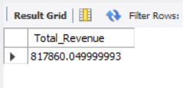

1. Average Order Value-

SELECT ROUND(SUM(total_price) / COUNT(DISTINCT order_id),2)

AS Average_Order_Value FROM pizza;

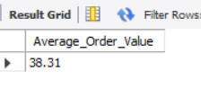

1. Total Pizzas Sold-

SELECT SUM(quantity) AS total_pizzas_sold FROM pizza;

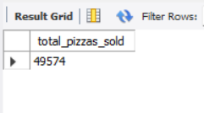

1. Average pizza per Order-

SELECT

SUM(quantity) / COUNT(DISTINCT order_id) AS total_pizzas sold

FROM

pizza ;

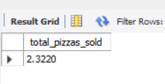

* 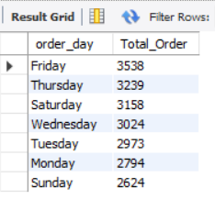**Trends Analysis of Pizza Orders-**

1. Daily Trend for pizza Orders-

SELECT

dayname(order_date) order_day,

COUNT(DISTINCT order_id) Total_Order

FROM

pizza

GROUP BY 1

Order by 2 DESC;

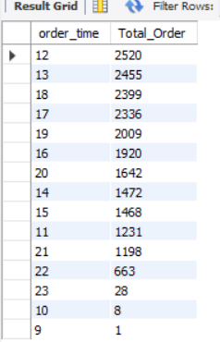

1. Hourly Trend for Pizza Orders-

SELECT

hour(order_time) order_time,

COUNT(DISTINCT order_id) Total_Order

FROM

pizza

GROUP BY 1

Order by 2 DESC;

1. 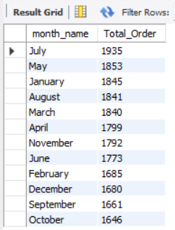Monthly trend for Pizza Orders-

SELECT

monthname(order_date) month_name,

COUNT(DISTINCT order_id) Total_Order

FROM

pizza

GROUP BY 1

Order by 2 DESC;

* **Percentage of Sales**

1. By Pizza Category-

SELECT

pizza_category,

(SUM(total_price) * 100 / (SELECT SUM(total_price) FROM pizza)) PCT

FROM

pizza

GROUP BY 1;

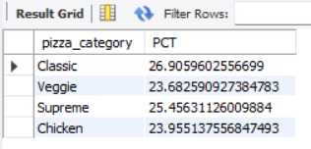

1. By pizza Size-

SELECT

pizza_size,

(SUM(total_price) * 100 / (SELECT SUM(total_price) FROM pizza)) PCT

FROM

pizza

GROUP BY 1;

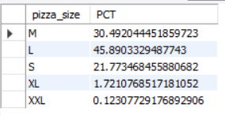

1. 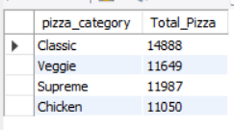Total Pizza sold by Category-

SELECT

pizza_category, SUM(quantity) Total_Pizza

FROM

pizza

GROUP BY 1;

* **Top Seller Pizzas by Sales**

1. 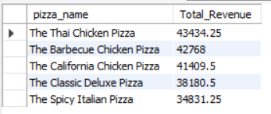Top 5 Pizzas by Total Revenue-

SELECT

pizza_name,

SUM(total_price) Total_Revenue

FROM

pizza

GROUP BY 1

ORDER BY 2 DESC

LIMIT 5;

1. 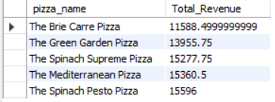Bottom 5 Pizzas by Total Revenue-

SELECT

pizza_name,

SUM(total_price) Total_Revenue

FROM

pizza

GROUP BY 1

ORDER BY 2 ASC

LIMIT 5

1. 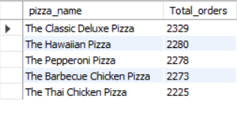Top 5 Pizzas by Total Orders-

SELECT

pizza_name,

COUNT(DISTINCT order_id) Total_orders

FROM

pizza

GROUP BY 1

ORDER BY 2 DESC

LIMIT 5

1. Bottom 5 Pizzas by Total Orders –

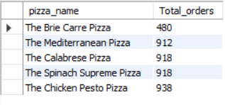SELECT

pizza_name,

COUNT(DISTINCT order_id) Total_orders

FROM

pizza

GROUP BY 1

ORDER BY 2 ASC

LIMIT 5;

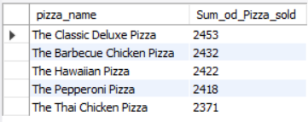

1. Top 5 Pizzas by Total Quantity Ordered -

SELECT

pizza_name,

SUM(quantity) Sum_of_Pizza_sold

FROM

pizza

GROUP BY 1

ORDER BY 2 DESC

LIMIT 5;

1. Bottom 5 Pizzas by Total Quantity Ordered-

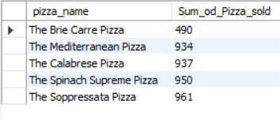SELECT

pizza_name,

SUM(quantity) Sum_of_Pizza_sold

FROM

pizza

GROUP BY 1

ORDER BY 2 Asc

LIMIT 5;